Experiment 8

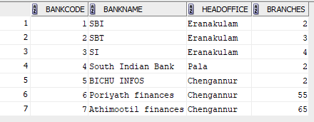

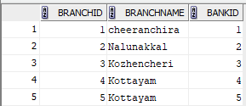

- create view bank_headoffice as select * from bank2 where headoffice='Eranakulam';

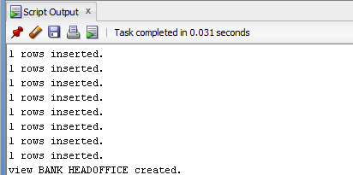

select * from bank_headoffice;

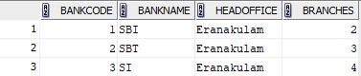

2. create view bank_banch as select * from bank2 join branch on bank
2.bankcode=branch.bankid;

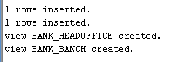

select * from bank_banch;

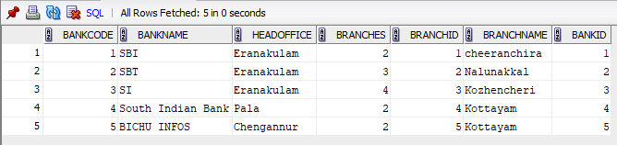

3.create view branches as select * from bank2 where branches>50;

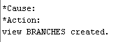

select * from branches;

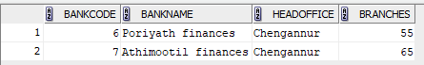

4. create view bank_branch as select bankname,branchname from bank2 join branch on bank2.bankcode=branch.bankid;

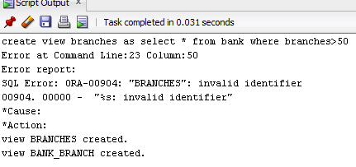
select * from bank_branch;
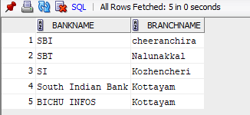

5. create view banks_heads as select * from bank2 where headoffice <> 'Eranakulam';
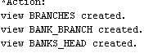

select * from banks_heads;
